ARAMARK
Riverside School District

Order Form

Date of Request ____________________

Event: ____________________________
Date: _____________________________
Time: _____________________________
Location: _________________________

Number of People _______

Contact Person: ____________________
Phone: ___________________________

Offerings:
_____Fresh Vegetable Platter w/Dip _____Fresh Fruit Platter w/Yogurt _____Cookie Tray (reduced fat)
_____Asst. Snack Basket
_____Capri Suns
_____Cupcakes (traditional)

Paper Needs:
_____Forks
_____Plates
_____Napkins
_____Cups

_____ (#) x _____(cost) = _______ Total



ARAMARK
Riverside School District

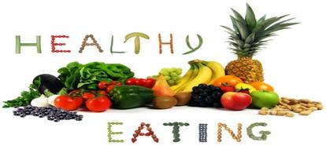

Party Planning Menu

In compliance with Riverside School District’s Wellness Policy, the Food Service Department has put together a variety of offerings that are sure to meet everyone’s party needs.

Items listed are ideas & suggestions. Your requests are welcome. We are capable of providing many additional services not listed. GIVE US A CALL! (570) 562-1031

Orders will be delivered and set up. Orders include all necessary utensils and condiments in quantities consistent with your order. Disposable products are used.

Ordering Information
Arrangement should be made at least 5 days in advance, but we will make every effort to accommodate last minute orders.

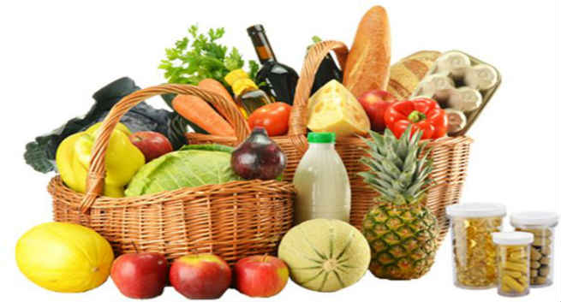

Please contact Food Service for order form and/or any questions or concern.

Thank you for choosing ARAMARK Classic Fare Catering. Our Goal is to exceed your expectations, as well as provide you with Quality, Appealing Food and Excellent Service. We appreciate your business!

Offerings
Fresh Vegetable Platter w/Dip
Includes a Variety of Fresh Vegetables and Low Fat Dip
$2.75/student

Fresh Fruit Platter w/Dip
Includes a Variety of Familiar Fresh Fruits in Season and Low Fat Yogurt Dip
$2.75/student

Cookie Tray
Asst. Fresh Baked Otis Spunkmeyer Whole Grain Reduced Fat Cookies.
$7.00/dozen

Assorted Snack Basket
Includes Baked Chips, Sunchips, Pretzels, Popcorn, and other Healthy Snacks.
$.85/student

Assorted Beverages
Capri Sun Juice Bags & Bottled Water.
$.75/student

Fresh Baked Cupcakes
Fresh Baked Cupcakes with Homemade Icing. No Trans Fats. Vanilla or Chocolate.
$8.00/dz and $4.00 each additional half dz.

